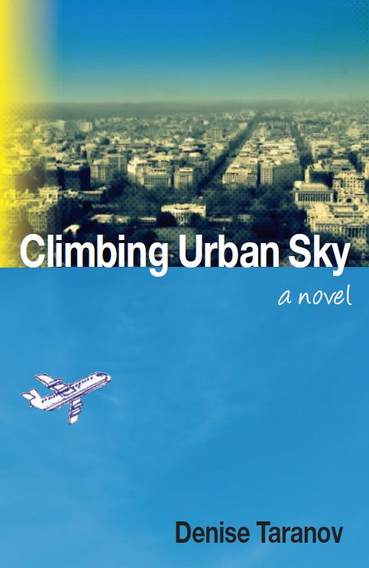
Discussion Guide
Climbing Urban Sky by Denise Taranov

- What is your overall impression of the novel?

- In what ways did the Arapaho legend tie into the novel? In what way(s) was Eleanor’s journey different than the Arapaho girl’s?

- What do you think motivated Eleanor’s decision on where to live in each phase of the novel?

- Try listening to the songs listed at the front of the book while or just after reading the respective chapters. In what way does the music influence what you feel or experience in your reading?

- What impression and/or analogy did you draw from the blurred line between art and life in the novel? What was the sculpture girl’s relationship to Eleanor?

- How did Eleanor change from the beginning of the novel to the end?

- What do you think ended up being different in Eleanor’s experience than what she imagined on the flight to Washington DC at the start of the novel?

- Which experiences in the story are the most relatable for you?

